Slip, Trips and Falls Training Handout

OSHA maintains general industry regulations on walking / working surfaces that guard against hazards including clutter, protruding objects, and wet conditions. These hazards can harm everyone in a facility, regardless of title or job.

Slips, trips, and falls cause nearly 700 fatalities per year and many more injurious accidents in the workplace according to the Bureau of Labor Statistics.

There are three physical factors involved in slips, trips, and falls: friction, momentum, and gravity. Each one plays a role. Friction is the resistance between objects, momentum is affected by the speed and mass of an object, and gravity is the force exerted on an object by the Earth.

Slips

- Slips are a loss of balance caused by too little friction between your feet and the surface you walk or work on. Loss of traction is the leading cause of workplace slips.
- Slips can be caused by wet surfaces, spills, or weather hazards like ice or snow. Slips are more likely to occur when you hurry or run, wear the wrong kind of shoes, or don’t pay attention to where you’re walking.

You can help avoid slips by following these safety precautions:

- Practice safe walking skills Take short steps on slippery surfaces to keep your center of balance under you and point your feet slightly outward.
- Clean up or report spills right away. Even minor spills can be very dangerous.
- Don’t let grease accumulate at your workplace.
- Be extra cautious on smooth surfaces such as newly waxed floors with enough momentum to be thrown off balance.

Trips

- Trips occur whenever your foot hits an object and you are moving with enough momentum to be thrown off balance. Trips are more likely to happen when you are in a hurry and don’t pay attention to where you’re going.

To prevent trip hazards:

- Make sure you can see where you are walking. Don’t carry loads that you cannot see over.
- Keep walking and working areas well lit, especially at night.
- Keep the workplace clean and tidy. Store materials and supplies in the appropriate storage areas.
- Arrange furniture and office equipment so that it doesn’t interfere with walkways or pedestrian traffic in your area. Clear walkways, stairs, and lobbies of anything that might be a tripping hazard, such as cords, wires, empty boxes, and clutter.
- Make sure that floor mats lay flat rather than wrinkled or bunched.

- Use handrails when you walk up and down steps. Before using any ladder or stepladder, make sure it opens fully.
- Properly maintain walking areas, and alert appropriate authorities regarding potential maintenance related hazards.

Falls

- Falls occur whenever you move too far off your center of balance. Falls account for more workplace fatalities than any other reason.

To avoid falls consider the following measures:

- Don’t jump off landings or loading docks. Use the stairs.
- Repair or replace stairs or handrails that are loose or broken.
- Keep passageways and aisles clear of clutter and well lit.
- Wear shoes with appropriate non-slip soles.
- Stay physically active.
- Try balance and strength training exercises.
- Have your eyes and hearing tested.
- Find out about the side effects of any medicines you take.
- Get enough sleep.
- Avoid or limit alcohol.
- Stand up slowly.

Distracted Walking

Distracted walking is any time a person is walking and not staying alert to their surroundings. This can mean being on a phone call, texting, listening to loud music, reading, or being too in-depth in conversation with others around you.

The dangers of distracted walking are the same as they are for driving. Despite our insistencies that we are great multitaskers, the human brain still can process only a few things at a time. Walking and texting caused more than 11,000 injuries last year.

Defensive Walking

Defensive Walking means walking in a manner that identifies and evaluates all possible situations that increase the risk of being injured, especially involving motor vehicles. Defensive walking also includes taking proactive steps to help mitigate the likelihood of being injured and responding to situations in an effective, protective manner.

How to Become a Defensive Walker

1. Put Your Phone Down – As tempting as it is to use your phone while you walk, it’s more
important to be alert of the environment around you. Whatever phone call you need to take or
text you need to send can wait until you have arrived safely at your destination.
2. Trust Yourself, Not the Driver – Trust your instincts over the drivers behind the wheel. If it might
be a close call to cross the street, don’t push it; being a few minutes late to your destination is
worth much more than experiencing severe or fatal injuries. Rely on yourself, not the driver to
slam on his / her brakes.
3. Take Off Your Headphones – Listening to music is an enjoyable pastime, but doing so while
walking down the street as a pedestrian is not the time nor the place. Keeping your ears and
eyes alert while crossing an intersection can help you identify dangerous situations and react proactively.
4. Look and Look Again – Do a double take! Cars move swiftly, so always remember to look twice;
it could save your life. The car you spotted a mile down the road could be moving much quicker
than initially expected.
5. Cross at Designated Crosswalks – Jaywalking may be a convenient option, but it’s not a safe one.
Taking the extra few minutes to use a crosswalk and can significantly help lower your risk of an
accident.
6. Bring a Friend – Walking in groups increases pedestrian visibility.
7. Dress to Impress – Reflective or bright clothing can help drivers identify you. Carrying a
flashlight can also help visibility and mitigate slip, trip, and fall accidents by helping you identify
any uneven surfaces.
8. Make Eye Contact with Drivers – Locking eyes with oncoming drivers can help you evaluate how
safe it is to cross and confirm they are aware of your presence. It’s not creepy, it’s your safety!

7 Science-Approved Tips for Walking Across Ice

1. Move Slowly and Steadily – Minimizing forward and backward force is indeed essential when
walking on ice. “What’s key is trying to keep force applied to the ground more vertically so
there’s less force forward and backward – because that’s the part that requires friction.”
2. Take Shorter Steps – The forces applied against the ground in forward and backwards directions
is reduced when you take shorter steps. You are not pushing as hard and are adapting your gait
to work with the reduced friction that is available to you.
3. Avoid Melting Ice – Ice is much slipperier when it’s melting. This isn’t to say you won’t ever slip
on ice the colder the temperature gets. It’s not that it’s not slippery, it’s just that it’s not as
slippery as when it’s warmer.
4. Go Around Slops and Stairs When You Can – Gravity is going to do it’s thing whether you like it or
not,” Philip E. Martin, Ph.D., Professor, and chair of the Department of Kinesiology at Iowa State
University says, especially if there’s an icy slope that’s in a significantly downhill direction.
Unfortunately, in this circumstance you probably won’t be able to adapt your gait to prevent
slipping, so it’s likely it’ll be a sore of Ice 1, Human 0.

5. Keep an Eye Out for Changing Surfaces – There are circumstances where the surface
characteristics can change without us realizing it. Don’t fret if you’re walking on a straight, dry
surface and suddenly encounter an icy patch you weren’t expecting. Maximum friction force is
reduced when you encounter this abrupt change, causing you to quickly alter your gait. Sure,
you may slip a little since it initially throws you off guard, but “humans are pretty adaptable and
recognize challenges quickly,” Martin says. We pay closer attention to surface characteristics
than we may consciously realize, and we adjust our stride patterns automatically.
6. Wear the Right Shoes – Rigid leather soles are far from ideal as they offer a significantly weaker
grip compared to a rubber sole. Traction-improving treads, cleats, or spikes can help too.
7. When All Else Fails, Waddle! – Consider taking an ice-walking cue from those waddling tuxedoed
ice pros: Walk Like a Penguin! Shuffling helps keep your weight in a straight-down stance,
allowing your feet to carry your weight carefully and minimize slipping.

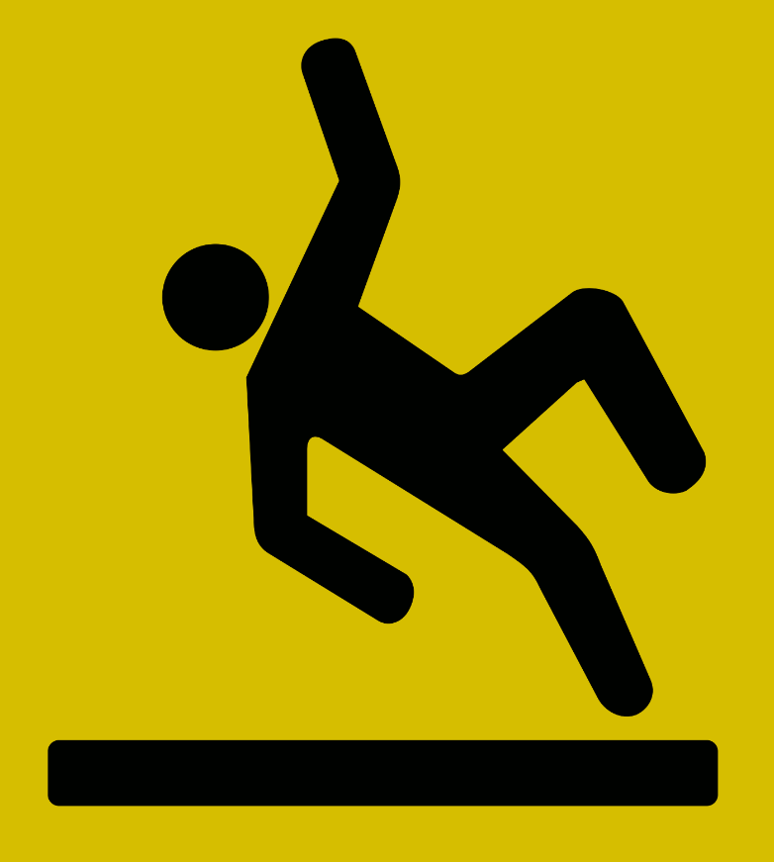

September 26, 2023
Slip, Trips and Falls Test

Name: Date:

1. __________ True or False – The three physical factors involved in slips, trips and falls is friction,
momentum, and gravity.

2. __________ are more likely to happen when you are in a hurry and don’t pay attention to where you’re
going.

a. Slips B. Trips C. Falls

3. You can help avoid slips by following these safety precautions:

a. Take short steps on slippery surfaces.
b. Clean up spills when you see them.
c. Be extra cautious on smooth surfaces.
d. All above.

4. To help prevent trips, you can:

a. If a floor mat is bunched up, walk around it and ignore it.
b. Walk slow when you are carrying a load that you cannot see over.
c. It is okay to store supplies in walkways, as long as they are pushed to the side.
d. Use handrails when you walk up and down steps.

5. To avoid falls, consider the following measures:

a. Wear shoes with appropriate non-slip soles.
b. Stand up slowly.
c. Find out about the side effects of any medicines you take.
d. All above.

6. __________ True or False – Distracted Walking can mean being on a phone call, texting, listening to
loud music, reading or being too in-depth in conversation with others around you.

7. __________ True or False – Defensive Walking is any time a person is walking and not staying alert
to their surroundings.

8. To become a Defensive Walker:

a. Trust the Driver, Not Yourself
b. Put Your Phone Down
c. Put on Your Headphones
d. Jaywalk

9. __________ True or False – Walking like a penguin helps to prevent you from slipping on ice.

10. __________ True or False – Melting ice means that you are less likely to slip.
Slip, Trips and Falls Test – Answer Key

Name: Date:

1. __________ True or False – The three physical factors involved in slips, trips and falls is friction,
momentum, and gravity.

2. __________ are more likely to happen when you are in a hurry and don’t pay attention to where you’re
going.

a. Slips B. Trips C. Falls

3. You can help avoid slips by following these safety precautions:

a. Take short steps on slippery surfaces.
b. Clean up spills when you see them.
c. Be extra cautious on smooth surfaces.
d. All above.

4. To help prevent trips, you can:

a. If a floor mat is bunched up, walk around it and ignore it.
b. Walk slow when you are carrying a load that you cannot see over.
c. It is okay to store supplies in walkways, as long as they are pushed to the side.
d. Use handrails when you walk up and down steps.

5. To avoid falls, consider the following measures:

a. Wear shoes with appropriate non-slip soles.
b. Stand up slowly.
c. Find out about the side effects of any medicines you take.
d. All above.

6. __________ True or False – Distracted Walking can mean being on a phone call, texting, listening to
loud music, reading or being too in-depth in conversation with others around you.

7. __________ True or False – Defensive Walking is any time a person is walking and not staying alert
to their surroundings.

8. To become a Defensive Walker:

a. Trust the Driver, Not Yourself
b. Put Your Phone Down
c. Put on Your Headphones
d. Jaywalk

9. __________ True or False – Walking like a penguin helps to prevent you from slipping on ice.

10. __________ True or False – Melting ice means that you are less likely to slip.

